Q1 For the South Region, create a Bar chart showing total sales by Sub-Category for every category. Sorting the Sub-category in descending order by Profit, determine the top sub-category for every category along with its Sales values in Thousands(K).

[Hint: Nested Sorting. Also break down the question line by line and solve it. 3 answers expected]

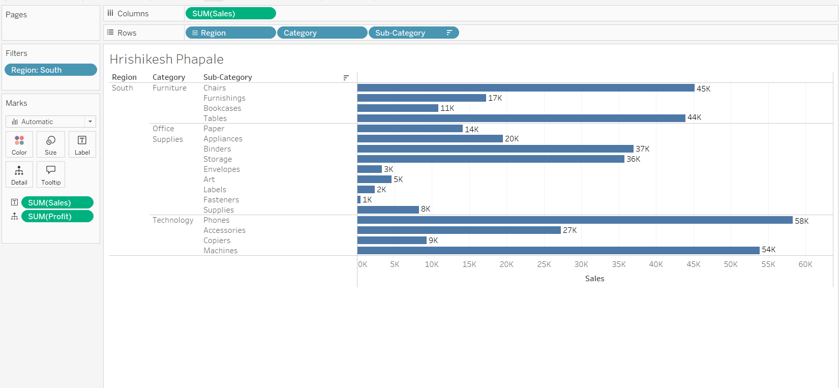

Q2 Using the Sample-Superstore dataset, determine if the 2021 sales numbers were expected to decrease by 23% in the following year across all the Segments. What would be the projected sales for the Corporate Segment in 2022? Crosstab should have 2 columns, 2021 sales and projected Sales by Segment.

❌ 543,733

❌ 159,472

✔️ 186,223

❌255,567

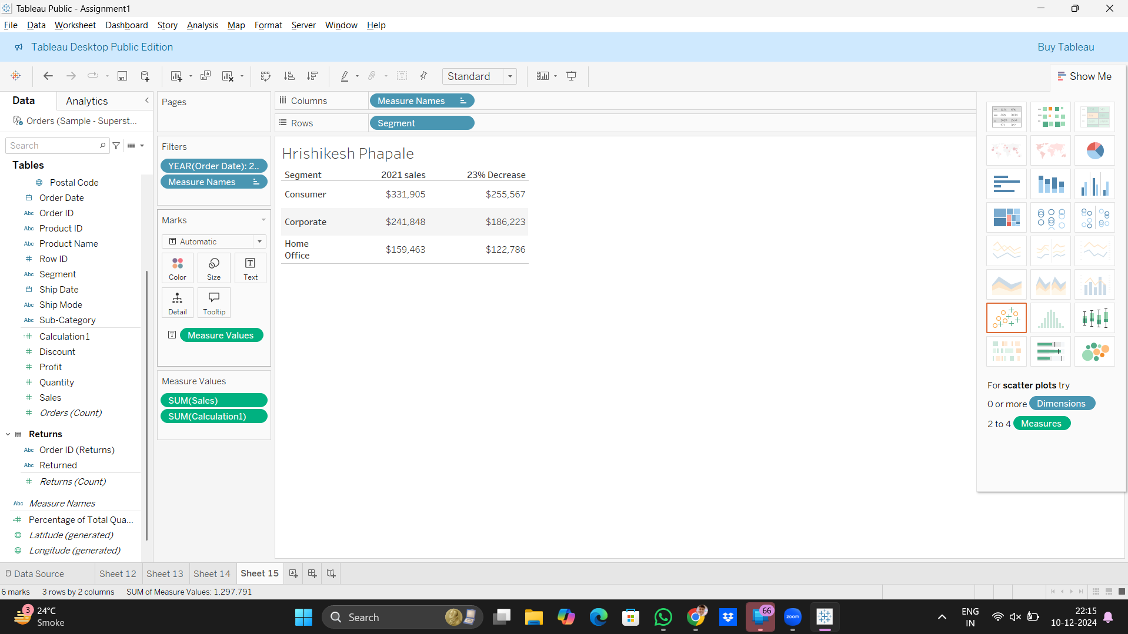

Q3 Using Parameters, what would be the approximate customer count in the United States for the State of California in 2021, if the numbers were expected to increase by 35% in the following year? Also, then estimate what would be the numbers if there is only 3% increase? [Output should have values for 35% and 3%]

✔️ 393 for 35%

✔️ 300 for 3%

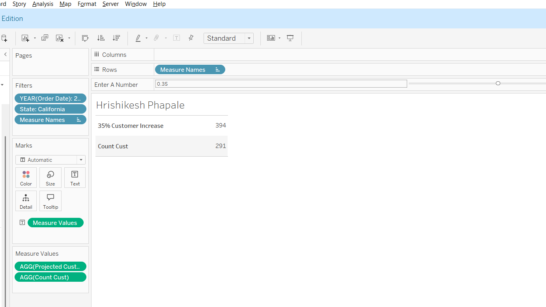

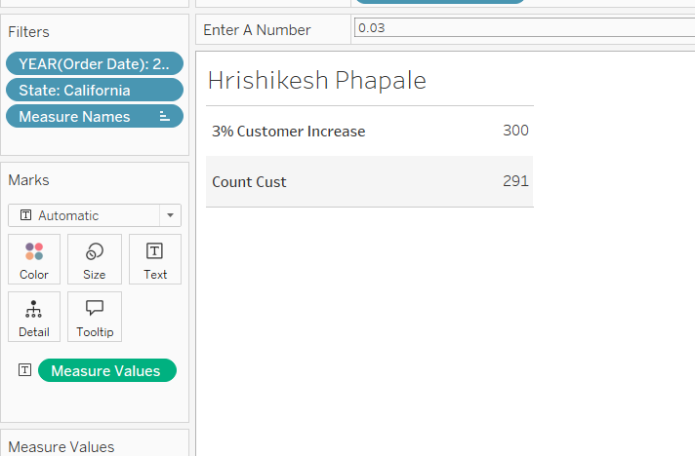

Q4 Using the Sample-Superstore dataset, determine which product under the category Office Supplies has the highest Profit ratio for the Sub-Category Art?

❌ Xerox 1890

❌Prang Dustless Chalk Sticks

✔️ Sanford Uni-Blazer View Highlighters, Chisel Tip, Yellow

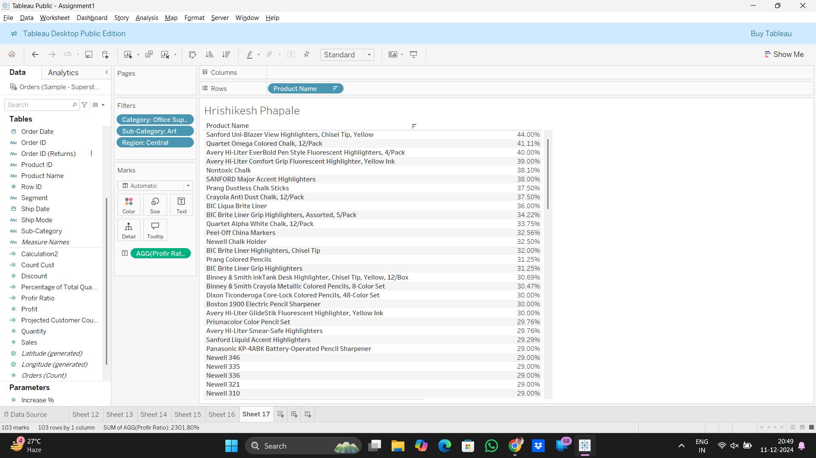

Q5 Using the Sample-Superstore dataset, for the customer with the highest Profit under Sub-Category 'Binders', what is his Profit Ratio?

❌47.53%

❌40.71%

❌50.00%

✔️ 48.68%

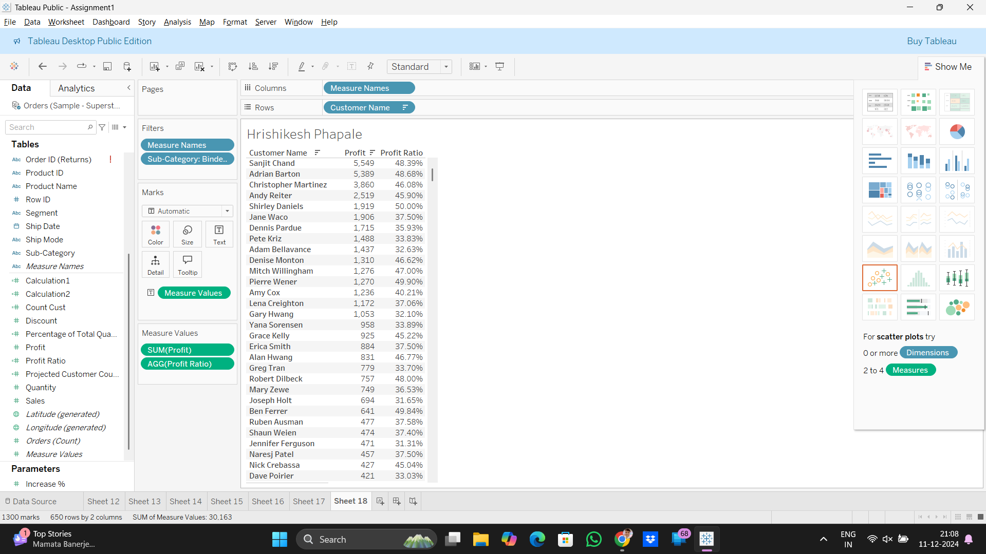

Q6 Using the Sample-Superstore dataset, what is the average number of days between the order date and the ship date for the Texas State? Also, highlight the cell only for the Texas State in orange color.

✔️ 3.9

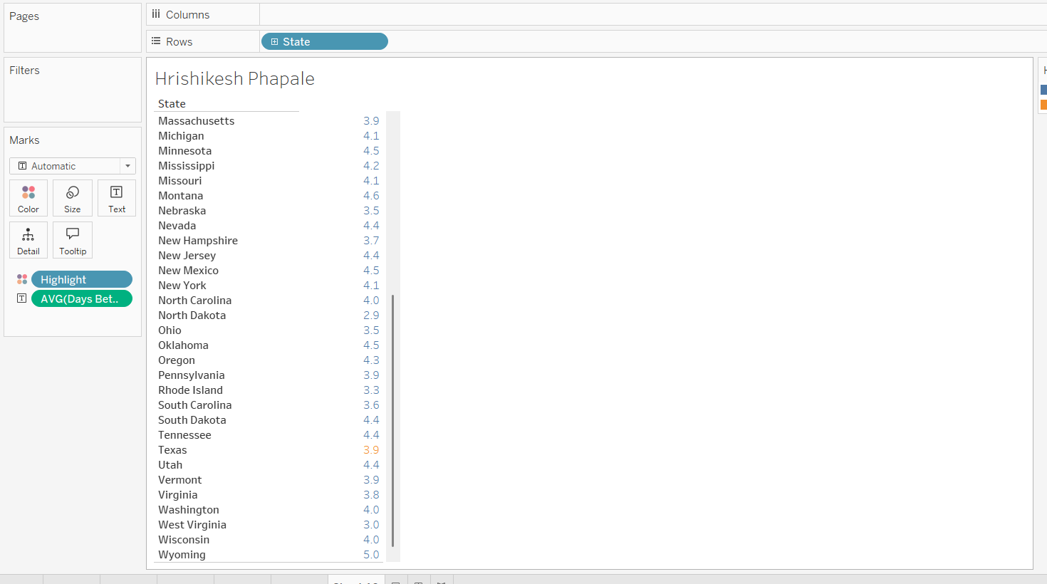

Q7 Using the Sample-Superstore dataset, which customer is associated with the highest number of distinct states? What is the COUNT?

✔️ Dean Percer 11

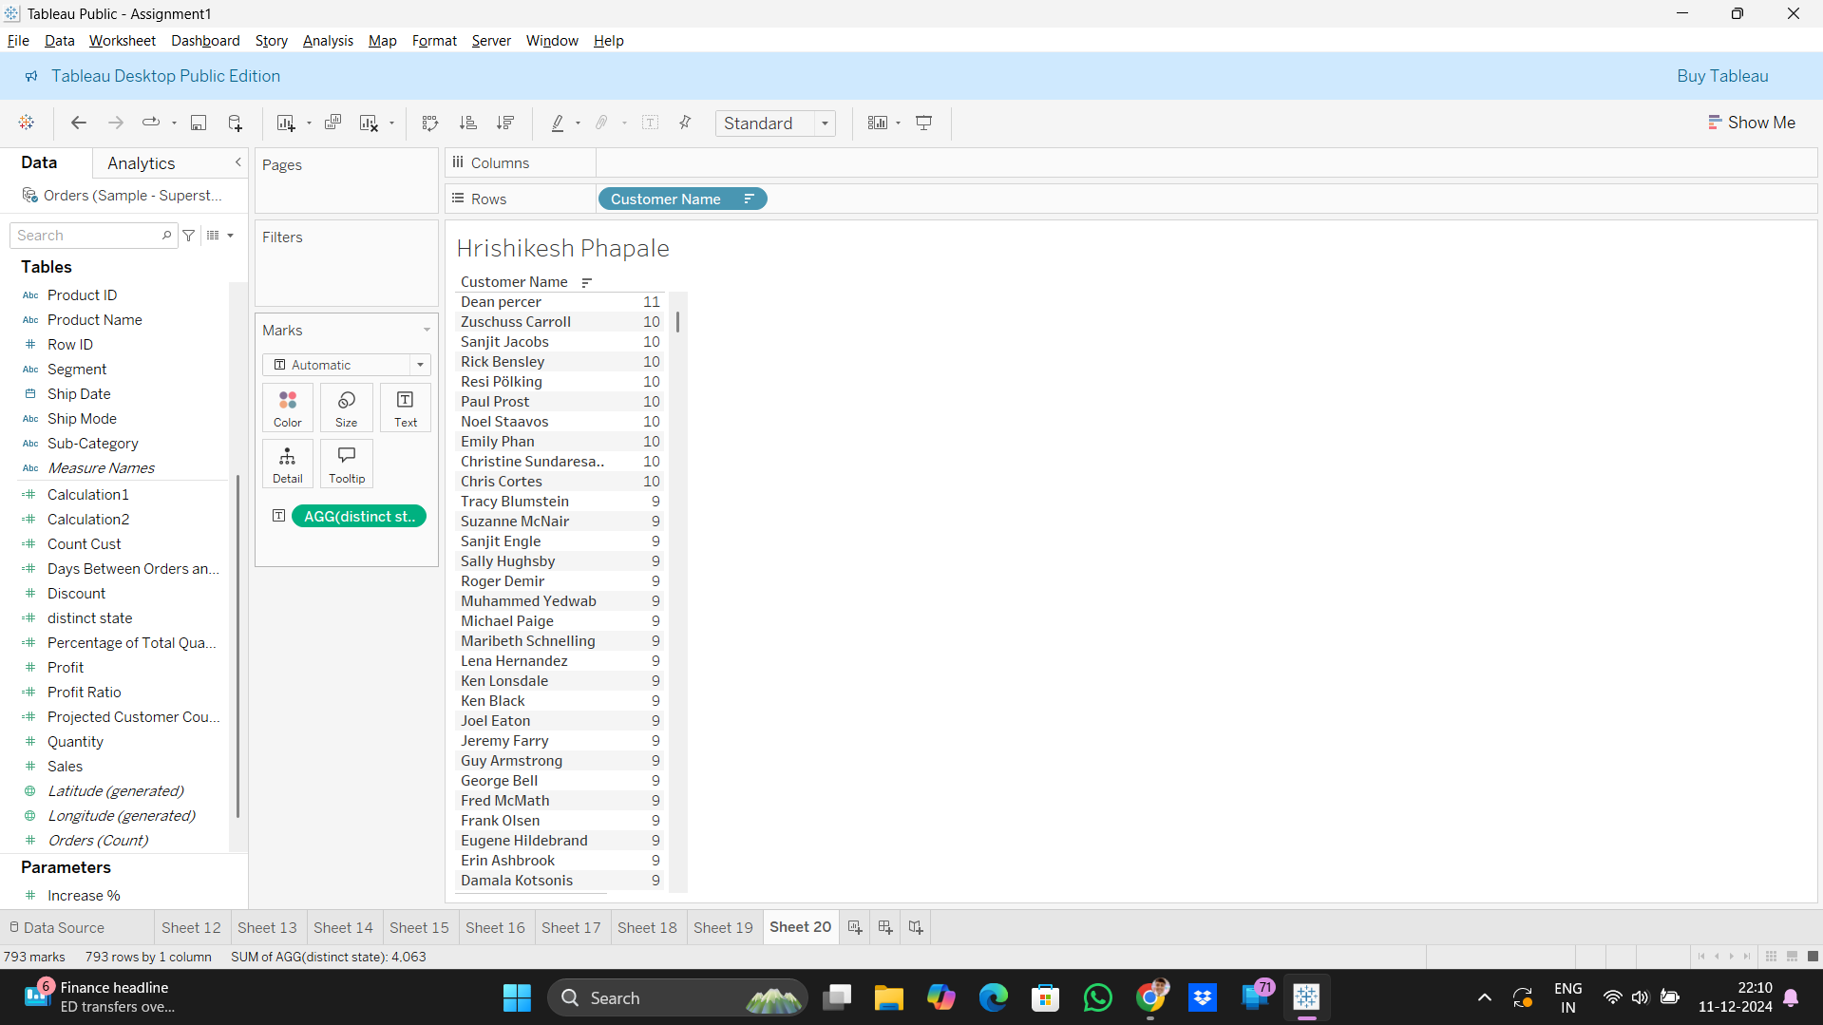

Q7 Using the Sample-Superstore dataset, which customer is associated with the highest number of distinct states? What is the COUNT?

✔️ Dean Percer 11